INTELLIGENT RETAIL SALES FORECASTING AND DECISION SUPPORT SYSTEM
MAJOR PROJECT REPORT
Submitted by
ANANYA S S
Bachelor of Computer Applications (BCA)
Project Description
This project presents an intelligent retail sales forecasting system that predicts future product sales using Machine Learning algorithms. The system analyses historical sales data, performs data preprocessing, feature engineering, model training, and provides accurate sales predictions through an interactive Flask web application. The project assists retailers in making better inventory planning and business decisions.
Tools and Technologies Used
Python
Pandas
NumPy
Matplotlib
Scikit-learn
Flask
HTML
CSS
Joblib
Project Domain
Machine Learning | Data Science | Web Development
Academic Year
2026–2027
CERTIFICATE
This is to certify that the Major Project entitled "Intelligent Retail Sales Forecasting and Decision Support System" is an original work carried out by Ananya S S as part of the Bachelor of Computer Applications (BCA) curriculum.
The project has been developed using Machine Learning techniques to analyse historical retail sales data and predict future sales. The implementation includes data preprocessing, exploratory data analysis, model training, evaluation, and deployment of the prediction model using the Flask web framework.
To the best of our knowledge, this project is an original work and has not been submitted previously, either in whole or in part, for the award of any degree, diploma, or certification.
Submitted by
ANANYA S S
Bachelor of Computer Applications (BCA)
Academic Year: 2026–2027

ACKNOWLEDGEMENT
I express my sincere gratitude to everyone who supported and encouraged me during the successful completion of this Major Project titled "Intelligent Retail Sales Forecasting and Decision Support System."
I would like to thank Jyesta Technologies for providing me with the opportunity to work on this project through the Molecule Learning Management System (LMS). This project has provided me with valuable practical knowledge and hands-on experience in Machine Learning, Data Science, and Web Application Development.
I also extend my heartfelt thanks to my family, friends, and well-wishers for their continuous encouragement, motivation, and support throughout the project.
Finally, I thank everyone who directly or indirectly contributed to the successful completion of this project.

ANANYA S S

ABSTRACT
The Intelligent Retail Sales Forecasting and Decision Support System is a Machine Learning-based application developed to predict future retail sales using historical sales data. Accurate sales forecasting helps retailers optimize inventory management, reduce stock shortages and overstock situations, and make informed business decisions.
The project begins with data collection and preprocessing, where missing values are handled and the dataset is prepared for analysis. Exploratory Data Analysis (EDA) is performed to understand sales patterns through visualizations such as sales trends, price distribution, promotion analysis, and store-wise performance.
Several Machine Learning regression algorithms, including Linear Regression, Decision Tree Regressor, Random Forest Regressor, and Gradient Boosting Regressor, are implemented and evaluated using performance metrics such as Mean Absolute Error (MAE), Root Mean Square Error (RMSE), and R² Score. The best-performing model is selected and saved for deployment.
A user-friendly web application is developed using the Flask framework, where users can enter details such as Store ID, Item ID, Price, Promotion, Day, Weekday, Month, and Year to obtain predicted sales instantly.
This project demonstrates how Machine Learning and web technologies can be integrated to build an intelligent decision support system that assists retailers in improving business planning, forecasting accuracy, and operational efficiency.
Keywords: Machine Learning, Retail Sales Forecasting, Flask, Random Forest, Data Science, Predictive Analytics, Decision Support System.

CHAPTER 1
INTRODUCTION
1.1 Introduction
Retail sales forecasting is an essential process that helps businesses estimate future product demand based on historical sales data. Accurate sales forecasting enables retailers to make informed decisions regarding inventory management, pricing strategies, promotional activities, and resource planning. Traditional forecasting methods often rely on manual analysis and are less effective when handling large datasets or identifying complex sales patterns.
With the advancement of Machine Learning, sales forecasting has become more accurate and efficient. Machine Learning algorithms can analyse historical sales records, identify hidden trends, and generate reliable predictions for future sales. This allows businesses to reduce inventory costs, minimise stock shortages, avoid overstocking, and improve customer satisfaction.
The Intelligent Retail Sales Forecasting and Decision Support System is developed to predict future sales using historical retail sales data. The project performs data preprocessing, exploratory data analysis, feature engineering, model training, model evaluation, and prediction. Multiple Machine Learning regression algorithms are implemented and compared to identify the most suitable model. The best-performing model is then deployed using the Flask framework to provide an interactive web application where users can enter sales-related details and obtain predicted sales instantly.
This project demonstrates the practical application of Machine Learning and web technologies in solving real-world retail business problems and supporting data-driven decision-making.
1.2 Problem Statement
Retail businesses often face challenges in accurately predicting future sales due to changing customer demand, seasonal variations, pricing changes, and promotional activities. Incorrect sales forecasting may result in inventory shortages, excess stock, increased operational costs, and reduced profitability.
Manual forecasting techniques are time-consuming and may not provide accurate predictions for large datasets. Therefore, there is a need for an intelligent system that can analyse historical sales data and generate accurate sales forecasts using Machine Learning techniques.
1.3 Objectives
The main objectives of this project are:
To analyse historical retail sales data.
To perform data preprocessing and exploratory data analysis.
To identify important factors affecting product sales.
To develop and compare multiple Machine Learning regression models.
To evaluate model performance using MAE, RMSE, and R² Score.
To select the best-performing model for prediction.
To develop a Flask-based web application for predicting retail sales.
To assist retailers in making effective inventory and business decisions.
1.4 Scope of the Project
The scope of this project includes developing a Machine Learning-based system capable of predicting future retail sales using historical sales data. The system supports retailers by providing accurate sales forecasts based on user inputs such as Store ID, Item ID, Price, Promotion, Day, Weekday, Month, and Year.
The application can be used for inventory planning, demand forecasting, business analysis, and decision support. Although the current system uses historical retail sales data, it can be further enhanced by integrating real-time sales data, weather information, customer behaviour analysis, and advanced Deep Learning techniques to improve forecasting accuracy.
1.5 Project Methodology
The project follows a systematic Machine Learning workflow:
Data Collection: The retail sales dataset is collected and loaded into the system.
Data Preprocessing: Missing values are handled, unnecessary data is removed, and the dataset is prepared for analysis.
Exploratory Data Analysis (EDA): Graphs and visualisations are generated to understand sales trends and feature relationships.
Feature Engineering: Important input features are selected for training the Machine Learning models.
Model Development: Linear Regression, Decision Tree Regressor, Random Forest Regressor, and Gradient Boosting Regressor models are trained.
Model Evaluation: The models are evaluated using MAE, RMSE, and R² Score, and the best-performing model is selected.
Model Deployment: The trained model is saved and integrated with a Flask web application to provide real-time sales predictions through a user-friendly interface.

CHAPTER 2
LITERATURE SURVEY
2.1 Introduction
Literature survey is an important phase of any research or software development project. It involves studying existing research papers, journals, articles, and similar systems to understand the current approaches used for solving a particular problem. A literature survey helps identify the strengths and limitations of existing systems and provides a foundation for developing an improved solution.
In this project, various studies related to retail sales forecasting, machine learning algorithms, and decision support systems were reviewed. The survey focuses on understanding how historical sales data can be analysed to predict future sales accurately using different machine learning techniques.
2.2 Existing System
Traditional retail sales forecasting systems mainly depend on manual calculations, statistical methods, or simple spreadsheet-based analysis. These methods often use historical sales records to estimate future demand but fail to consider multiple influencing factors such as product price, promotional activities, store performance, seasonal variations, and customer purchasing patterns.
Many existing systems are capable of generating sales reports but do not provide intelligent predictions. Some systems use only a single prediction algorithm, which may not provide the best forecasting accuracy for different datasets. As a result, retailers often face difficulties in inventory planning and demand management.
2.3 Limitations of the Existing System
The major limitations of the existing system are:
Manual forecasting is time-consuming and prone to human errors.
Traditional statistical methods provide limited prediction accuracy.
Existing systems cannot effectively analyse large volumes of retail data.
Seasonal and promotional factors are not accurately considered.
Poor forecasting may result in stock shortages or excess inventory.
Many systems do not provide an interactive user interface for real-time predictions.
Decision-making becomes difficult due to inaccurate demand estimation.

2.4 Proposed System
The proposed system, Intelligent Retail Sales Forecasting and Decision Support System, uses Machine Learning techniques to predict future retail sales based on historical sales data. The system performs data preprocessing, exploratory data analysis, feature engineering, model training, and model evaluation before selecting the best-performing prediction model.
Multiple Machine Learning regression algorithms, including Linear Regression, Decision Tree Regressor, Random Forest Regressor, and Gradient Boosting Regressor, are implemented and compared using evaluation metrics such as Mean Absolute Error (MAE), Root Mean Square Error (RMSE), and R² Score.
The selected model is deployed using the Flask framework to develop a user-friendly web application. Users can enter input values such as Store ID, Item ID, Price, Promotion, Day, Weekday, Month, and Year to obtain instant sales predictions.
2.5 Advantages of the Proposed System
The proposed system offers several advantages over traditional forecasting methods:
Provides more accurate sales predictions using Machine Learning algorithms.
Reduces manual effort in forecasting future sales.
Supports better inventory management and demand planning.
Helps retailers make informed business decisions.
Performs faster prediction compared to manual methods.
Provides a simple and interactive web interface using Flask.
Compares multiple Machine Learning models to select the best-performing algorithm.
Can be extended in the future by integrating real-time sales data and advanced forecasting techniques.
2.6 Summary
The literature survey concludes that traditional sales forecasting methods have several limitations in terms of prediction accuracy and scalability. Machine Learning-based forecasting provides a more intelligent and reliable approach for analysing historical sales data and predicting future demand. The proposed system overcomes many of the shortcomings of existing methods by combining multiple Machine Learning algorithms with a Flask-based web application to provide accurate and user-friendly retail sales forecasting.

CHAPTER 3
SYSTEM ANALYSIS AND DESIGN
3.1 Introduction
System analysis and design is an important phase in software development that focuses on understanding the system requirements and designing an effective solution. It defines the architecture, components, technologies, and workflow of the proposed system. A well-designed system improves efficiency, accuracy, and usability.
The Intelligent Retail Sales Forecasting and Decision Support System is designed to analyse historical retail sales data and predict future sales using Machine Learning algorithms. The system provides a user-friendly web interface through which users can enter sales-related information and obtain accurate sales predictions.
3.2 System Architecture
The proposed system follows a Machine Learning-based architecture consisting of the following stages:
Data Collection
The historical retail sales dataset is collected and loaded into the system.
Data Preprocessing
Missing values are handled.
Unnecessary data is removed.
Data is prepared for model training.
Exploratory Data Analysis (EDA)
Various graphs and visualisations are generated to analyse sales patterns and relationships between features.
Feature Engineering
Important input features such as Store ID, Item ID, Price, Promotion, Day, Weekday, Month, and Year are selected.
Model Training
Linear Regression
Decision Tree Regressor
Random Forest Regressor
Gradient Boosting Regressor
Model Evaluation
Models are evaluated using MAE, RMSE, and R² Score.
The best-performing model is selected.
Model Deployment
The trained model is saved as model(1).pkl.
The Flask web application loads the model and predicts sales based on user input.
3.3 Hardware Requirements
The minimum hardware requirements for the proposed system are:
Processor : Intel Core i3 or above
RAM : 4 GB or higher
Storage : 20 GB free disk space
Operating System : Windows 10/11
Internet Connection : Required for dataset download and package installation
3.4 Software Requirements
The software requirements are:
Python 3.x
Visual Studio Code
Google Colab
Flask
Pandas
NumPy
Matplotlib
Scikit-learn
Joblib
HTML
CSS
Web Browser (Chrome, Edge, or Firefox)
3.5 Dataset Description
The dataset used in this project contains historical retail sales information collected from a retail store. It includes details such as Store ID, Item ID, Price, Promotion, Day, Weekday, Month, Year, and Sales.
The dataset is used to train Machine Learning models for predicting future sales. Before training, the dataset is preprocessed to improve data quality and model performance.
3.6 Input Design
The system accepts the following user inputs through the Flask web application:
Store ID
Item ID
Price
Promotion
Day
Weekday
Month
Year
These inputs are processed by the trained Machine Learning model to generate the predicted sales value.

3.7 Output Design
The output of the system is the predicted retail sales value. After entering the required information and clicking the Predict button, the application displays the estimated sales instantly on the result page.
This output helps retailers estimate future demand and make better inventory and business decisions.
3.8 System Workflow
The working process of the proposed system is as follows:
Load the retail sales dataset.
Perform data preprocessing.
Analyse the dataset using EDA.
Train multiple Machine Learning models.
Compare the performance of all models.
Select the best-performing model.
Save the trained model.
Deploy the model using Flask.
Accept user input.
Predict future retail sales.
Display the prediction result.
3.9 Summary
The system analysis and design describe the complete architecture, requirements, dataset, workflow, and implementation strategy of the proposed system. The combination of Machine Learning algorithms and the Flask web framework provides an efficient and user-friendly solution for retail sales forecasting and decision support.

CHAPTER 4
IMPLEMENTATION AND RESULTS
4.1 Introduction
This chapter explains the implementation of the Intelligent Retail Sales Forecasting and Decision Support System. The project was implemented using Python and Machine Learning techniques. Historical retail sales data was collected, preprocessed, analysed, and used to train multiple regression models. The best-performing model was deployed using the Flask framework to provide a user-friendly web application for predicting future retail sales.
4.2 Dataset Collection
The dataset used in this project consists of historical retail sales records. It contains information related to product sales, store details, pricing, promotional activities, and date-related attributes. The dataset was loaded into Google Colab using the Pandas library for further processing.
The dataset contains the following features:
Store ID
Item ID
Price
Promotion
Day
Weekday
Month
Year
Sales (Target Variable)
After loading the dataset, its structure, dimensions, and data types were verified before preprocessing.
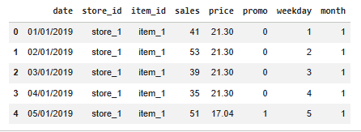

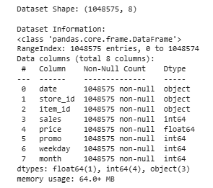

4.3 Data Preprocessing
Data preprocessing was performed to improve the quality of the dataset before training the Machine Learning models. Missing values were identified and handled appropriately. The dataset was checked for inconsistent values and converted into a suitable format for model training.
The preprocessing steps included:
Loading the dataset
Checking missing values
Removing unnecessary records
Converting data into appropriate formats
Preparing the dataset for Machine Learning
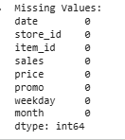
4.4 Exploratory Data Analysis (EDA)
Exploratory Data Analysis was carried out to understand the characteristics of the dataset and identify relationships between different variables. Various graphical visualisations were generated to analyse sales trends and feature distributions.
The following graphs were created:
Date-wise Sales Trend
Month-wise Sales Analysis
Store-wise Sales Analysis
Average Sales by Promotion
Price Distribution
Correlation Heatmap
These visualisations helped in identifying important sales patterns and selecting suitable input features for the prediction model.
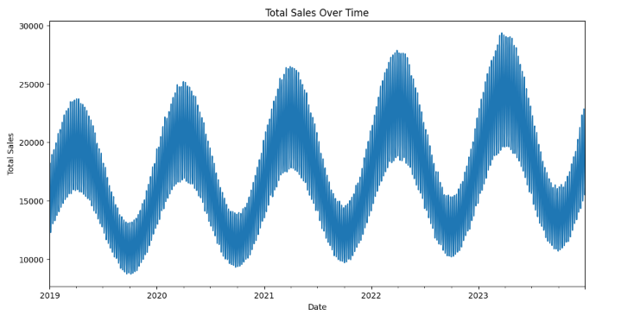

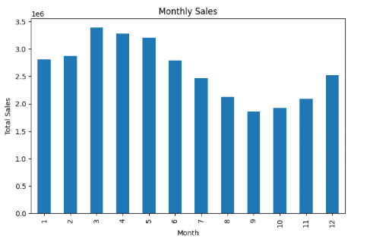

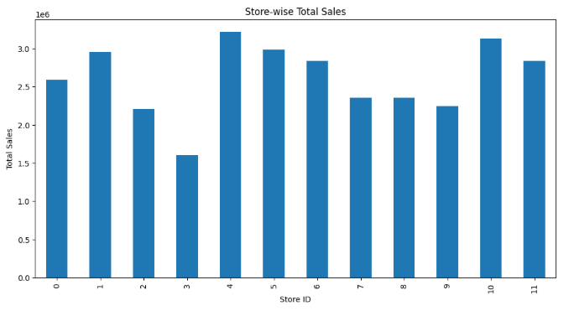

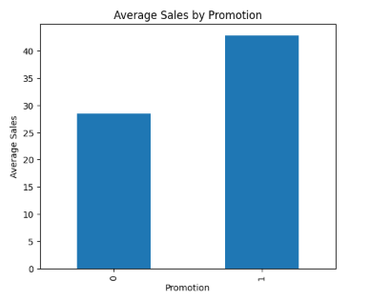

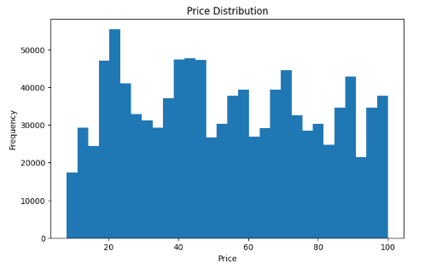
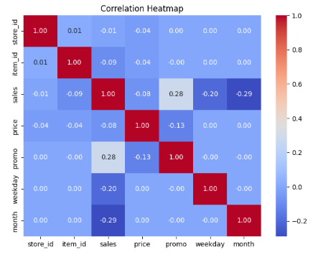

4.5 Model Development
Several Machine Learning regression algorithms were implemented and trained using the processed dataset. The objective was to compare their prediction performance and identify the most suitable model.
The following algorithms were used:
Linear Regression
Decision Tree Regressor
Random Forest Regressor
Gradient Boosting Regressor
Each model was trained using the training dataset and tested using unseen data.
4.6 Model Evaluation
The performance of each Machine Learning model was evaluated using standard regression evaluation metrics.
The evaluation metrics used were:
Mean Absolute Error (MAE)
Root Mean Square Error (RMSE)
R² Score
Based on these evaluation metrics, the best-performing model was selected for deployment.
(Insert Screenshot: Model Comparison Results)
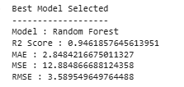
4.7 Model Deployment
After selecting the best-performing Machine Learning model, it was saved as model.pkl using the Joblib library. The trained model was integrated into a Flask web application.
The web application accepts user inputs such as:
Store ID
Item ID
Price
Promotion
Day
Weekday
Month
Year
The application processes these inputs and generates the predicted sales instantly.
4.8 User Interface
A simple and user-friendly web interface was developed using HTML, CSS, and Flask.
The application provides:
Input form for entering sales-related information
Prediction button
Display of predicted sales result
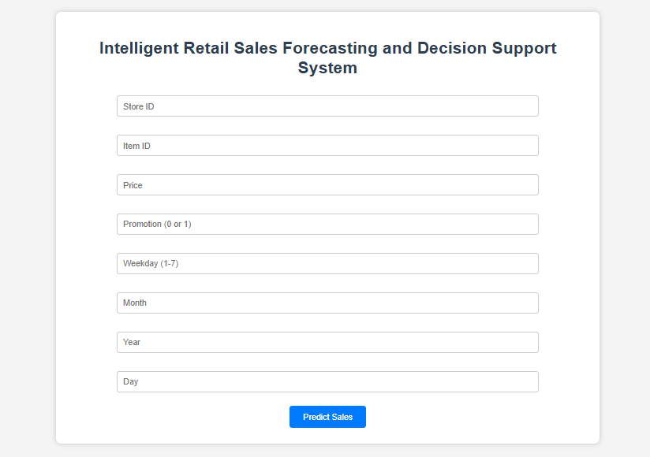

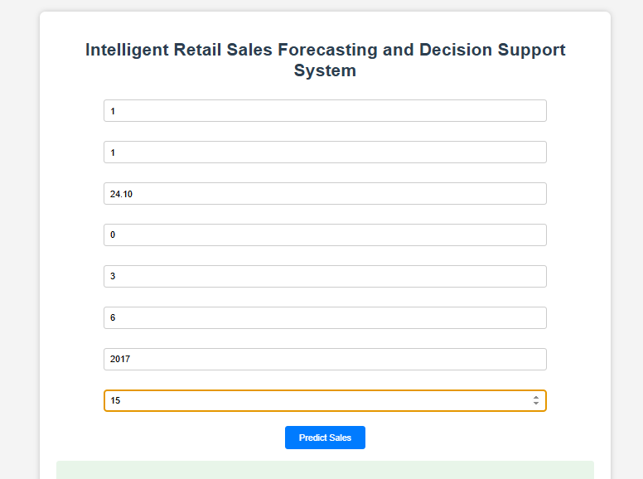

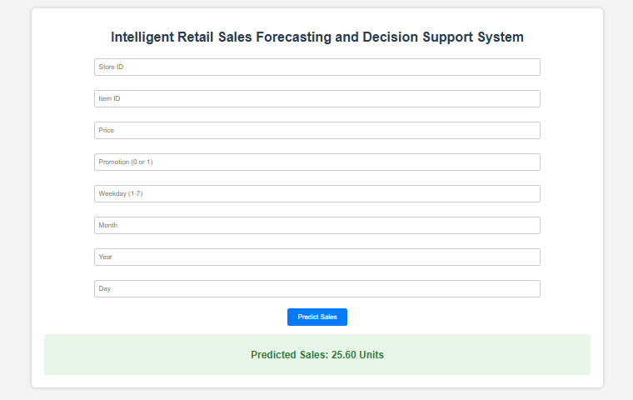
4.9 Results and Discussion
The developed system successfully predicts future retail sales based on user-provided input values. Multiple Machine Learning models were compared, and the best-performing model was deployed in the Flask web application.
The application provides fast and accurate predictions, helping retailers estimate future demand and make better inventory and business decisions. The integration of Machine Learning with a web application demonstrates the practical implementation of predictive analytics in the retail sector.
4.10 Summary
This chapter presented the complete implementation of the proposed system, including dataset collection, preprocessing, exploratory data analysis, model development, model evaluation, deployment, and user interface. The results demonstrate that the system effectively predicts retail sales and serves as a useful decision support tool for retailers.

CHAPTER 5
CONCLUSION AND FUTURE SCOPE
5.1 Conclusion
The Intelligent Retail Sales Forecasting and Decision Support System was successfully developed using Machine Learning techniques and deployed as a web application using the Flask framework. The project effectively analyses historical retail sales data to predict future sales based on user-provided inputs such as Store ID, Item ID, Price, Promotion, Day, Weekday, Month, and Year.
The project included data preprocessing, exploratory data analysis, feature engineering, model training, and model evaluation. Multiple Machine Learning algorithms, including Linear Regression, Decision Tree Regressor, Random Forest Regressor, and Gradient Boosting Regressor, were implemented and compared using performance metrics such as Mean Absolute Error (MAE), Root Mean Square Error (RMSE), and R² Score. The best-performing model was selected and integrated into the Flask application.
The developed system provides a simple and user-friendly interface that enables users to obtain sales predictions quickly and accurately. This helps retailers improve inventory planning, demand forecasting, and business decision-making. The project demonstrates the practical application of Machine Learning and web technologies in solving real-world retail forecasting problems.
5.2 Future Scope
The proposed system can be further enhanced in the future by implementing the following improvements:
Integrate real-time sales data for more accurate forecasting.
Include weather conditions and festival seasons as additional prediction factors.
Develop a mobile application for easier access to predictions.
Connect the system with cloud databases for online data storage.
Implement Deep Learning algorithms such as LSTM for advanced time-series forecasting.
Generate interactive dashboards and business reports for better data visualisation.
Provide automated inventory management recommendations based on predicted sales.
Deploy the application on a cloud platform so that users can access it from anywhere.
5.3 Summary
The project successfully achieved its objectives by developing an intelligent retail sales forecasting system capable of providing reliable sales predictions. The combination of Machine Learning algorithms and the Flask web framework resulted in an efficient, accurate, and user-friendly application. With future enhancements, the system can become a more comprehensive business decision support solution for the retail industry.

REFERENCES
Use these references in APA-style or simple format:
Aurélien Géron, Hands-On Machine Learning with Scikit-Learn, Keras & TensorFlow, O'Reilly Media, 3rd Edition.
Gareth James, Daniela Witten, Trevor Hastie, and Robert Tibshirani, An Introduction to Statistical Learning, Springer.
Wes McKinney, Python for Data Analysis, O'Reilly Media.
Scikit-learn Documentation – https://scikit-learn.org/⁠�
Pandas Documentation – https://pandas.pydata.org/⁠�
Flask Documentation – https://flask.palletsprojects.com/⁠�
NumPy Documentation – https://numpy.org/⁠�
Matplotlib Documentation – https://matplotlib.org/⁠�

APPENDIX
Appendix A: Project Tools and Technologies
The following software and technologies were used to develop the project:
Python 3.x
Google Colab
Visual Studio Code
Flask
Pandas
NumPy
Matplotlib
Scikit-learn
Joblib
HTML
CSS
Appendix B: Dataset Features
The dataset contains the following attributes:
Sl.No. | Attribute | Description
1 | Store ID | Unique identifier of the store
2 | Item ID | Unique identifier of the product
3 | Price | Price of the product
4 | Promotion | Promotion status(0=No,1=Yes)
5 | Day | Day of the month
6 | Weekday | Day of the week
7 | Month | Month of the year
8 | Year | Year of the sale.
9 | Sales | Target value representing product sales.

Appendix C: Software Modules
The project consists of the following modules:
Dataset Loading
Data Preprocessing
Exploratory Data Analysis
Feature Engineering
Machine Learning Model Training
Model Evaluation
Model Deployment
Flask Web Application
Sales Prediction
Appendix D: Project Output
The application successfully predicts retail sales based on user input and displays the predicted sales value through a Flask web interface.

